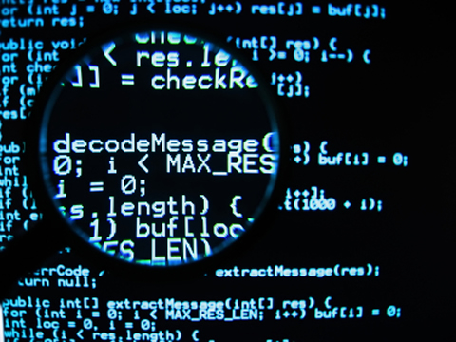

Reverse Code Engineering

Want to get started with a new approch ?

Do you feel that programming is'nt fun ?

Bored of theories want to try your skills ?

Don't you know the power of R.C.E. ?

Do you want to develop your software analysis skills ?

Reverse engineering is the process of discovering the technological principles of a device, object, or system through analysis of its structure, function, and operation. It often involves taking something (e.g., a mechanical device, electronic component, software program, or biological, chemical, or organic matter) apart and analyzing its workings in detail to be used in maintenance, or to try to make a new device or program that does the same thing without using or simply duplicating (without understanding) the original.

Why Reverse Code engineering? : It is always very important to work inside the budget of the project, sometimes it's not that easy . . . By reverse engineering you can actually reverse any pre exisisting binaries and get the code you want and use it in your project which will be really handy !

Why This WorkShop ? : This workshop will get you started with Reverse Code Engineering. All the basic knowledge and prerequisites will be provided to help you ease through the detail of the subjet.This workshop will help you get into the new era of technology.

What will you learn ?

1. Some important things about life that covers Software approch
2. How computer works? Friendship with computers. . . .
3. Software Engineering ( No the bookiesh concepts )
4. Analysis of any existing software
5. Some basics of assambly language
6. How to think when you are reversing any thing
7. Developing a different mindset towards softwares
8. Controlled Debugging and Execution
9. Overview of tools used
10. Example of a software CRACK!!!!
11. Summary

FEES:- Rs 100/head

DURATION:- 2 HOURS

DAY:- 30th MARCH

TIME:- 2 pm to 4 pm